NAME LINDOKUHLE
SURNAME: GABUZA
STUDENT NUMBER: ST10536739
GROUP: 4
MODULE NAME: WEB DEVELOPMENT
MODULE CODE: WEDE5020

PROJECT PROPOSAL 2

Table of Contents
1. ORGANIZATION OVERVIEW 2
• Name of organization 2
• MISSION STATEMENT 3
• VISSION STATEMENT 3
• TARGET MARKET 3
2. WEBSITE GOALS AND OBJECTIVES 3
The website goals and objectives are as follows: 3
Key Performance Indicators (KPIs) 3
3. CURRENT WEBSITE ANALYSIS 4
4. PROPOSED WEBSITE FEATURES AND FUNCTIONALITY 4
5. DESIGN AND USER EXPERIENCE 4
USER EXPERIENCE CONSIDERATIONS 5
6.TECHNICAL REQUIREMENTS 5
7.TIMELINE AND MILESTONES 5
8.BUDGET 6
9.REFERENCES 6

ORGANIZATION OVERVIEW
- Name of organization: SoleDrop
SoleDrop is a fictional sneaker and streetwear retail store founded by a group of sneaker enthusiasts passionate about street culture and urban fashion. What began as a small pop-up store at local markets has grown into a recognised brand within the sneaker community. SoleDrop specialises in limited edition sneakers, and streetwear for everyday fashion lovers.

MISSION STATEMENT
“To connect sneaker culture enthusiasts with premium streetwear, and a community built around style and self-expression.”

VISSION STATEMENT
“To be the most trusted and culturally relevant sneaker and streetwear destination in the region.”

TARGET MARKET
Individuals aged 16-35 both males and females, who are fans of brands such as Nike, Adidas, New Balance, etc. The business is mostly aimed at university students and young professionals with disposable income and who are also sneaker collectors and streetwear enthusiasts

WEBSITE GOALS AND OBJECTIVES

The website goals and objectives are as follows:
- Create an online presence that reflects the brand’s streetwear identity and culture
- Showcase available and upcoming sneaker drops
- Drive product enquiries and in-store visits
- Build a loyal community of followers and repeat customers

Key Performance Indicators (KPIs)
- Monthly Website visitors: 3,000+ unique visitors within 3 months of launch
- Enquiry Form Submissions: 30+ per month
- Average Session Duration: 2 minutes or more
- Bounce Rate: Below 50%

CURRENT WEBSITE ANALYSIS

SoleDrop is a fictional organization with no existing website. Currently, the brand relies entirely on Instagram and WhatsApp to communication with customers about new stock and drop dates. These limits reach and professionalism.

PROPOSED WEBSITE FEATURES AND FUNCTIONALITY
- HOMEPAGE: Navigation, Bold hero image, featured drops
- Enquiry Page: Form to enquire about product availability, size, or reservations
- PRODUCT DETAIL PAGE: Sneaker and streetwear listings, Size guide, Real-time stock availability per size, Save to Wishlist
- ABOUT US PAGE: Brand history, mission and vision, and team overview
- CONTACT PAGE: Contact form, store locations, business hours, and social media links

DESIGN AND USER EXPERIENCE

COLOUR SCHEME
- Dark Charcoal & Off-White
TYPOGRAPY
- Headings: Bebas Neue
- Body text: Robot
LAYOUT AND DESIGN APPROACH
SoleDrop’s website will use a dark-themed, high-contrast layout that reflects streetwear aesthetics. The Products page will feature a grid layout with hover effects and filter option

USER EXPERIENCE CONSIDERATIONS
- Mobile-first design given the predominantly younger, mobile-using audience
- Sticky navigation with a hamburger menu on menu
- Quick-load product cards with image, name, price visible at glance

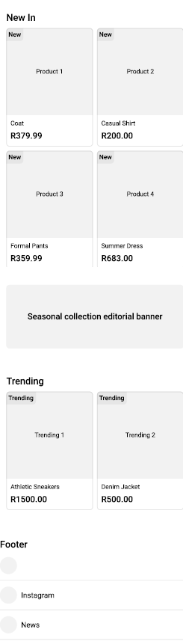

6.TECHNICAL REQUIREMENTS

PROGRAMING LANGUAGES AND FRAMEWORK
- HTML, CSS, JavaScript for web structure and styling

7.TIMELINE AND MILESTONES

PART ONE
- WEEK 1: Research, planning, and finalising proposal
- WEEK 2-3: Contant research and sourcing, Website structure and planning
- WEEK 4-5: Testing and debugging
PART TWO
- WEEK 1-2: Working through feedback from part one and CSS styling for desktop
- WEEK 3-4: Responsive design
PART THREE
- WEEK 1-2: Working through feedback from part 2 and functionality
- WEEK 3-5: Search engine optimization and forming functionality and validation

8.BUDGET

- DOMAIN NAME (.CO .ZA/.COM): R100 – R300/year
- Web Hosting: R800 – R2,500/year
- Website Maintenance & support: R500 - R2,000/month
- SSL Certificate: Often included in hosting
- SEO/Marketing Services: R1,000 – R5,000+/month
Estimated total (one-time development cost): R12,000 – R30,000+
Estimated Monthly Running Costs: R7,000+

9.REFERENCES
Brand forge(2025).website design prices South Africa 2025
Available at:www.thebrandforge.co.za [online]

